Dancing Light
Abstract
WS2812B addressable RGB LEDs are great for indoor and outdoor decorating purposes. It would be a great choice if you want to control 1000s of RGB LEDs using a single data line. WS2812B RGB LED only needs a single data line to control all the LEDs connected in series.
WS2811 is the old version with an external IC. It often comes with 12v packages.
WS2812 is nothing but WS2811 placed inside a 5050 LED package.
WS2812B is an improved version of WS2812. It inherited all the good qualities of WS2812 and improved the IC mechanically, further enhancing the stability and efficiency.
And SK6812 is a clone of WS2812B.

Requirments:
RGB LED Strip with WS2812 Driver
Electret Microphone Breakout Board
Arduino UNO

RGB LED Strip:

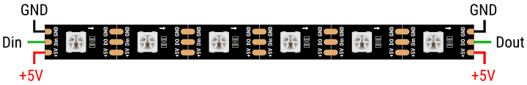

WS2812B has a control circuit and RGB chip integrated into a package of 5050 components. This package contains four pins – VCC, Ground, DIN, and DOUT.
WS2812B has an internal digital latch and a signal reshaping circuit. It also includes an electric reset circuit and a power lost reset circuit.
The data transfer protocol uses a single NZR communication mode. After the pixel gets the reset signal, the DIN port receives data from the controller. The first pixel collects the initial 24-bit data and sends it to the internal data latch. The other data is reshaped by the internal signal reshaping circuit and sent to the next cascade pixel through the Dout pin. After transmission for each pixel, the signal reduces to 24bit.

Arduino Uno:
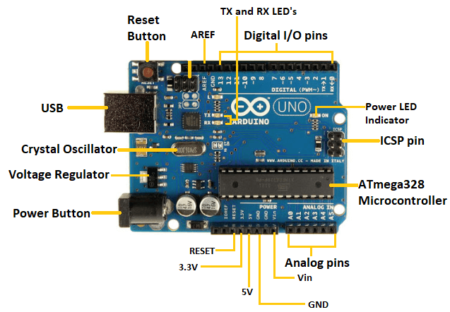
Arduino UNO is a microcontroller board based on the ATmega328P. It has 14 digital input/output pins (of which 6 can be used as PWM outputs), 6 analog inputs, a 16 MHz ceramic resonator, a USB connection, a power jack, an ICSP header and a reset button. It contains everything needed to support the microcontroller; simply connect it to a computer with a USB cable or power it with a AC-to-DC adapter or battery to get started.
Replaceable chip
The ATmega328P can easily be replaced, as it is not soldered to the board.
EEPROM
The ATmega328P also features 1kb of EEPROM, a memory which is not erased when powered off.

MIC Sensor:
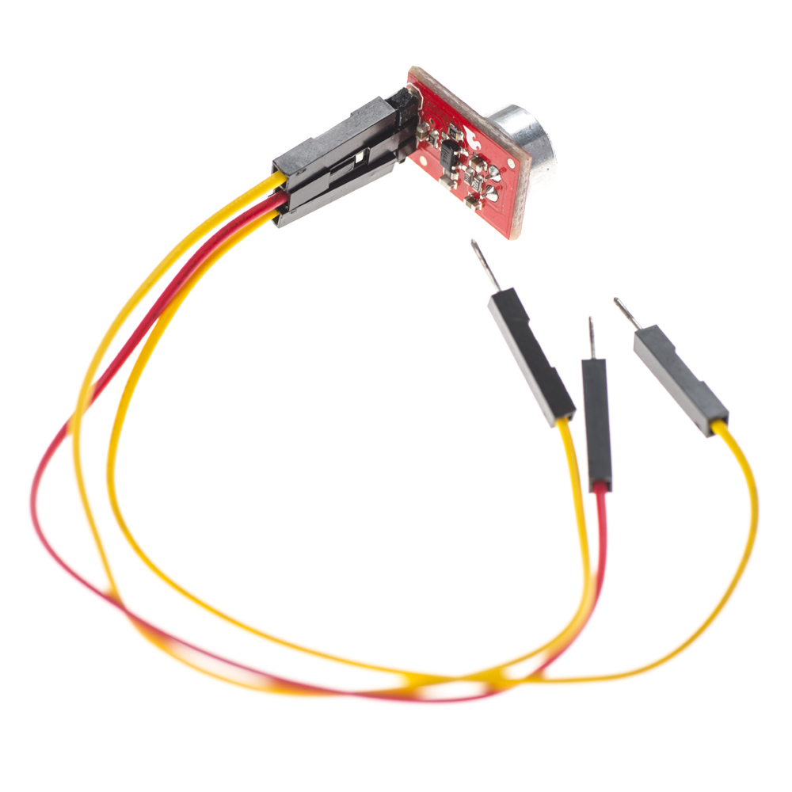
Monitoring and security systems such as door alarms, burglar alarms, et cetera. Consumer electronics, for example, music systems, computers, and phones. Sound level recognition and ambient sound recognition.

Circuit Diagram:
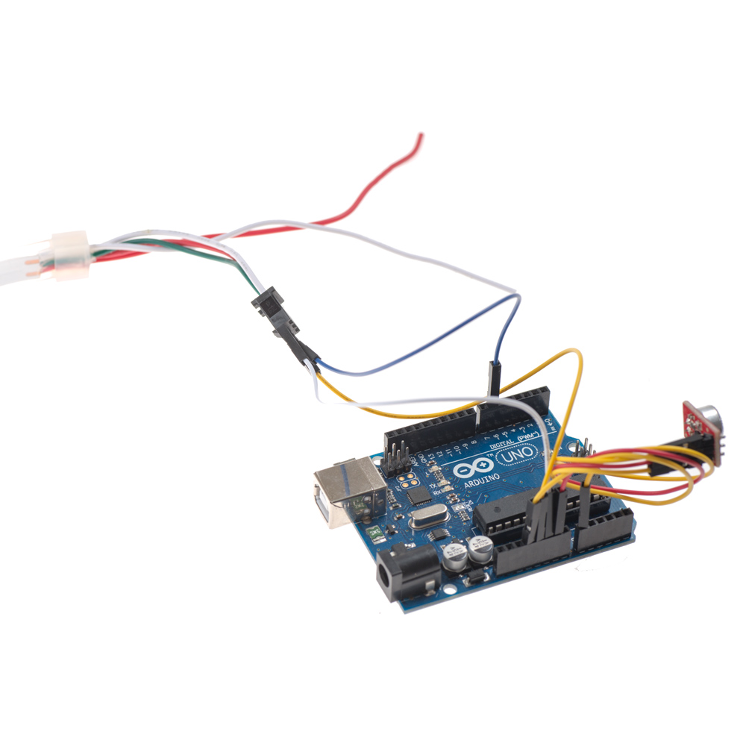

Code:


Conclusion:
It works on the principle of charging and discharging of capacitors C1 and C2. Current from the positive of battery flows through first set of LEDs D1-D3 to the collector of Transistor1 through resistor R1. Resistor R1 limits current through the LEDs to protect them.
Dancing LED circuit can be used for any visual sign indication in any highways or it can be used in advertisement hoarding also. LED blinking circuit can be used in signaling purpose (It can be used as signal for help, if you are in danger) LED blinking circuit can be used as flashing beacon.

